**GCD of Two Numbers**

GCD (Greatest Common Divisor) or HCF (Highest Common Factor) of two numbers is the largest number that divides both of them.

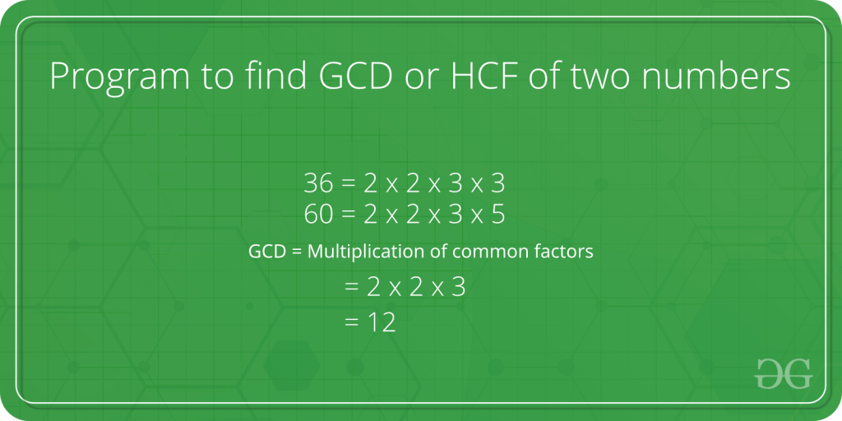

For example, GCD of 20 and 28 is 4 and GCD of 98 and 56 is 14.

C++

#include<iostream>

using namespace std;

int main()

{

int a, b;

cin >> a >> b;

int x = min(a,b);

int ans = 1;

for(int i = 1; i<=x; i++){

if(a%i==0 and b%i==0)

ans = i;

}

cout << ans;

return 0;

}

**INPUT :**

15 6

**OUTPUT :**

3